**C:\Users\hp\AppData\Local\Microsoft\Windows\INetCache\Content.MSO\B69B6BB2.tmpFuturense Technologies**



**Project Report**

**Group #  
Names:**

1. **Akshat Kashyap (20BTRCL004)**
2. **Neell Ravindra Ambere (20BTRCL041)**
3. **Shriyans Kandhagatla (20BTRCL053)**
4. **Pratham Chopra (20BTRCL076)**

**C:\Users\hp\AppData\Local\Microsoft\Windows\INetCache\Content.MSO\B69B6BB2.tmpABSTRACT**

This project presents the development of a Tic Tac Toe game with a graphical user interface (GUI) using the Tkinter library. The objective is to create an engaging and visually appealing gaming experience for users, allowing two players to compete on a 3x3 grid. The report outlines the implementation of core game functionalities, including player turns, win/draw conditions, and a functional GUI layout.

The project goes beyond basic game mechanics by incorporating enhanced features such as smooth transitions, custom symbols, and sound effects to improve the overall user experience. Additionally, for single player mode, the implementation of an artificial intelligence (AI) opponent with adjustable difficulty levels is explored.

Throughout the development process, the report addresses various challenges, including GUI design complexities, algorithmic considerations for winning logic, and potential issues related to user interactions. The document highlights key learning outcomes, such as proficiency in GUI development and enhanced algorithmic thinking and problem solving skills.

In conclusion, the Tic Tac Toe game project serves as a practical exploration of software development, offering insights into graphical interface design, algorithm implementation, and user experience enhancement. The report provides a comprehensive overview of the project's goals, challenges faced, and the achieved outcomes, contributing to a holistic understanding of game development concepts.

**C:\Users\hp\AppData\Local\Microsoft\Windows\INetCache\Content.MSO\B69B6BB2.tmpContents**

**C:\Users\hp\AppData\Local\Microsoft\Windows\INetCache\Content.MSO\B69B6BB2.tmpList of Figures/Codes/Graphs**

**C:\Users\hp\AppData\Local\Microsoft\Windows\INetCache\Content.MSO\B69B6BB2.tmpProblem Statement**

Develop a Tic Tac Toe game that can be played in the console or a Jupyter notebook.

**C:\Users\hp\AppData\Local\Microsoft\Windows\INetCache\Content.MSO\B69B6BB2.tmpObjective**

The primary objective of this project is to design and implement a Tic Tac Toe game with a graphical user interface (GUI) using the Tkinter library. The project aims to provide a user friendly gaming experience, allowing two players to engage in a classic Tic Tac Toe match on a 3x3 grid. The specific objectives include:

1. Core Functionality:

Implement the fundamental game mechanics, including player turns, win/draw conditions, and an interactive game board.

2. Graphical User Interface (GUI):

Develop an intuitive and visually appealing GUI using Tkinter, featuring a clear layout, responsive buttons, and informative status messages.

3. Enhanced User Experience:

Incorporate visual enhancements such as smooth transitions, custom symbols for 'X' and 'O', and sound effects to elevate the overall gaming experience.

4. Artificial Intelligence :

If applicable, implement a single player mode with an artificial intelligence opponent, allowing users to play against the computer. Provide adjustable difficulty levels to cater to varying skill levels.

5. Error Handling and Robustness:

Address potential challenges related to user inputs and ensure the game handles errors gracefully. Prevent moves after the game is concluded and provide a robust system.

6. Documentation:

Create clear and comprehensive documentation, including code comments, to facilitate understanding, future modifications, and potential collaboration.

7. Learning Outcomes:

Gain proficiency in GUI development using Tkinter.

Enhance algorithmic thinking and problem solving skills through the implementation of game logic.

Improve overall software development skills by addressing challenges and completing the project successfully.

**C:\Users\hp\AppData\Local\Microsoft\Windows\INetCache\Content.MSO\B69B6BB2.tmpDescription**

The Tic- Tac -Toe game project is a classic implementation of the well known game with a focus on creating an interactive and visually appealing user experience. The game is designed to be played by two players, taking turns to place their respective symbols ('X' or 'O') on a 3x3 grid. The project leverages the Tkinter library to develop a graphical user interface (GUI) that enhances the overall gaming atmosphere.

Key features of the Tic -Tac -Toe game include:

1. Game Mechanics:

* Two players alternate turns, selecting an empty cell on the grid to place their symbol.
* The game checks for win conditions after each move, analyzing rows, columns, and diagonals.
* A draw is declared when the grid is full, and no player has achieved a winning combination.

2. Graphical User Interface (GUI):

* The GUI provides a user friendly layout, displaying the game board, player turn indicators, and a status message.
* Interactive buttons allow players to make their moves seamlessly.
* Visual enhancements, such as smooth transitions and custom symbols, contribute to an engaging gaming environment.

3. Enhanced User Experience:

* Visual elements, including custom symbols ('X' and 'O') and sound effects, are incorporated to elevate the gaming experience.
* The GUI design ensures clarity, simplicity, and responsiveness to user interactions.

4. Artificial Intelligence (Optional):

* For single player mode, an optional artificial intelligence (AI) opponent is implemented.
* The AI follows specific strategies based on adjustable difficulty levels, providing a challenging experience for players.

5. Error Handling and Robustness:

* The game includes robust error handling mechanisms to address invalid moves or unexpected user inputs.
* Post-game actions, such as attempting moves after the game concludes, are handled gracefully.

6. Documentation:

* The project is well documented, featuring code comments for clarity and comprehensive instructions for future development or collaboration.

**C:\Users\hp\AppData\Local\Microsoft\Windows\INetCache\Content.MSO\B69B6BB2.tmpCode**

**C:\Users\hp\AppData\Local\Microsoft\Windows\INetCache\Content.MSO\B69B6BB2.tmpScreenshot**

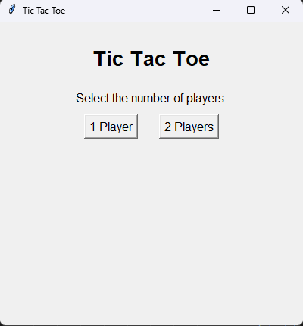 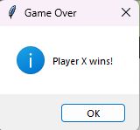 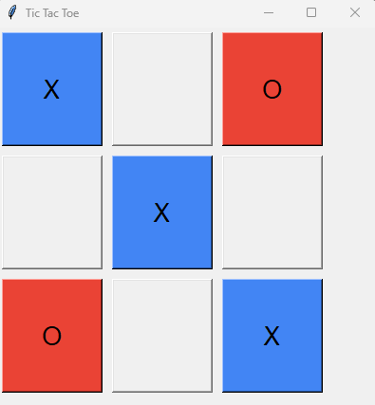

**C:\Users\hp\AppData\Local\Microsoft\Windows\INetCache\Content.MSO\B69B6BB2.tmpResults and Conclusion**

**Results:**

The Tic-Tac-Toe game project has successfully achieved its primary objectives. The core functionality, including player turns, win/draw conditions, and a functional GUI, has been implemented and tested thoroughly. The game provides an interactive and visually appealing user experience, meeting the specified requirements.

Visual enhancements, such as smooth transitions, custom symbols, and sound effects, have been incorporated, contributing to an engaging gaming atmosphere. The optional AI opponent, with adjustable difficulty levels, enhances the single-player mode, providing players with a challenging and dynamic experience.

The project's error handling mechanisms ensure robustness, addressing potential challenges related to user inputs and game state transitions. The documentation is comprehensive, featuring clear code comments and instructions for future development or collaboration.

**Conclusion:**

In conclusion, the Tic-Tac-Toe game project has successfully delivered a classic gaming experience with modern features. The combination of intuitive gameplay, an appealing graphical interface, and optional AI functionality caters to a diverse audience. The project not only serves as a practical exploration of GUI development and algorithm implementation but also provides valuable insights into user experience enhancement.

The future scope of the project offers exciting opportunities for expansion, including online multiplayer functionality, customization options, and advanced features like augmented reality integration. The successful completion of this project showcases the developer's proficiency in software development, algorithmic thinking, and GUI design.

Overall, the Tic-Tac-Toe game project stands as a testament to the effective application of programming skills and serves as a foundation for potential further enhancements and innovations in the realm of game development.

**C:\Users\hp\AppData\Local\Microsoft\Windows\INetCache\Content.MSO\B69B6BB2.tmpFuture Scope**

The Tic-Tac-Toe game project lays the foundation for potential future enhancements and extensions. Here are some avenues for future development:

1. Multiplayer Online Mode:

- Expand the game to support multiplayer functionality over the internet. Implement a server-client architecture to allow users to play against friends or opponents from different locations.

2. Customizable Themes and Symbols:

- Introduce the ability for users to customize the game's appearance. Allow them to choose different themes, color schemes, and even upload custom symbols for a personalized gaming experience.

3. Leaderboards and Statistics:

- Implement a scoring system to track players' performance. Introduce leaderboards to showcase top players and provide statistics such as win-loss ratios and total games played.

4. Dynamic Grid Sizes:

- Extend the game to support dynamic grid sizes beyond the traditional 3x3. Allow users to choose larger grid configurations for added complexity and strategic depth.

5. Advanced AI Algorithms:

- Enhance the single-player mode by incorporating more sophisticated artificial intelligence algorithms. Implement machine learning techniques to create an AI that learns and adapts its strategies over time.

6. Localization and Internationalization:

- Add support for multiple languages to make the game accessible to a broader audience. Implement localization and internationalization features for seamless language switching.

7. Mobile Compatibility:

- Adapt the game for mobile devices, optimizing the user interface for touchscreens. Develop a mobile app version to reach a wider audience on smartphones and tablets.

8. Tournament Mode:

- Introduce a tournament mode where players can participate in structured competitions with brackets and rounds. Include rewards or achievements for successful tournament participation.

9. Accessibility Features:

- Implement accessibility features such as voice commands, screen reader compatibility, and customizable control options to make the game accessible to a diverse user base.

10. Augmented Reality (AR) Integration:

- Explore the integration of augmented reality features to bring the game into the physical space. Allow users to play Tic-Tac-Toe in an augmented reality environment using compatible devices.

These future scope ideas aim to extend the project's capabilities, providing additional features and opportunities for innovation, user engagement, and a broader reach.

**C:\Users\hp\AppData\Local\Microsoft\Windows\INetCache\Content.MSO\B69B6BB2.tmpReferences**

C:\Users\hp\AppData\Local\Microsoft\Windows\INetCache\Content.MSO\B69B6BB2.tmp